Chemistry Unit 1 Worksheet Period: ______ Name: _______________________

Scientific Method Word Games

SCIENTIFIC METHOD WORD GAMES
Find as many of the words in the list as you can in the word hunt below.
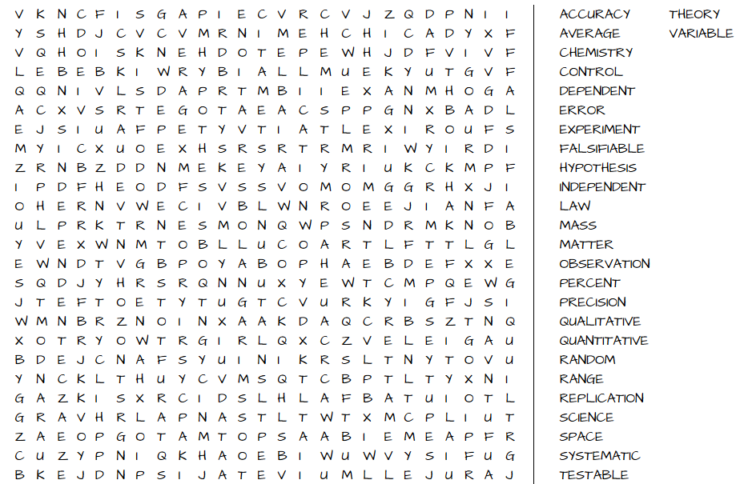

How many words can you make out of the letters in “Scientific Method”?

Match each of these vocabulary words with its definition below

- Accuracy
- Precision
- Quantitative
- Qualitative
- Independent variable
- Dependent variable
- Hypothesis
- Control
- Theory
- Law
- Average
- Range
- Percent error
- Systematic Error
- Random Error

- The variable that is changed or controlled in a scientific experiment. Plotted on the x-axis of a graph.
- The difference between the maximum and minimum values in a data set.
- A summary of many experimental results and observations that tells how things work.
- Errors (in either direction) in measured data due to the limitations of the measurement device.
- A well-substantiated explanation of some aspect of the natural world, based on a body of facts that have been repeatedly confirmed through observation and experiment.

- The variable being tested and measured in a scientific experiment. Plotted on the y-axis of a graph.
- Errors in data that are consistently in the same direction. Due to procedures or equipment used.
- The closeness of a measurement to the true value.
- A calculation expressing the typical value in a set of data.
- The closeness of agreement among a set of results.
- A theory or explanation that is based on observations and that can be tested.
- Data marked by the descriptive character of something rather than its numerical measurement.
- A measure of how close an experimental result is to an accepted or known value
- A case designed to check the results of an experiment by setting the independent variable to zero.
- Data marked by numerical measurements collected by using laboratory equipment.

